Department of Computer Science Year 2 - Term 1 SOFT20181: Internet Application Programming

Documentation

SOFT20181

Internet Application Programming

Supporting Documentation

N1347685

I hereby declare that I am the sole author of this report and that all third-party items including code have been adequately acknowledge and referenced.

Signature
Shaheerullah Fayzi

Table of Content
- Introduction
1.1 Success Criteria 2. Design Process
2.1 Initial Research
2.2. Initial Design (Justification)
2.2.1 Site Map
2.2.2 Wireframe 2.2.3 Moodboard
2.2.4 etc.
- Implementation
3.1 Features Developed, Implementation Processes and Challenges Encountered
- Summary and Conclusion
Sources and Reference
Appendix

Documentation

Link to Site on the UDON Server :- https://udon.ads.ntu.ac.uk/staff/cmp3aladet/website-1/web-1/
?

1.0 Introduction

This is the supporting documentation for the Event Booking Website created for SOFT20181 Internet Application Programming.

This Event Booking website is intended to promote Meetings, Bootcamps and conferences happening across all the UK. It consists of 4 pages built using a computer first approach, the website has been tested on several devices including phone and tablet. The Application has been written in HTML5 and is rendered using CSS. Client-side interaction is achieved using JavaScript and jQuery.

The website has been designed to be fully media responsive for optimal display on all sizes of device. Furthermore, all images have been pre-processed via optimisation and compression to reduce loading times and all code has been validated and contains no errors.
In addition, the website has been tested on devices with alternate resolutions and the faults discovered have been removed
1.1 Success Criteria
Everything on the website functions as intended
Success Criteria Point | Priority | Implemented?
Website Navigation | Required | Yes, a horizontal navigation bar across the top of the page which links to all internal pages
Customised Presentation | Required | Yes, background colour and font size of header elements across all pages can be controlled using JS and user preference stored using local storage API
Registration Form | Required | Yes, …
Product Price in other Currencies | Optional | No, all the prices are in GBP.
…

Sources and references for all material used can be found on the last page of the report.

Documentation

2.0 Design Process

2.1 Initial Research
Taking all specification from course work and inspecting existing event booking websites such as MeetUp. My aspiration was to My goal was to design a platform that simplifies the event discovery and booking process, fostering user engagement. Incorporating dynamic content, responsive design, and seamless navigation, the website caters to both event organizers and attendees.
The design of this web page is aimed for all audiences …
justifications
- The header is designed to ensure intuitive navigation, allowing users to access key pages quickly. (users experience considerations)
- Like on many Event Booking websites the menu page and all the events listed are built in a way that allows the user to see all the product types and be able to go to all pages and find what they are looking for [https://www.meetup.com/]…
2.2 Initial Design
Put together your sitemap, wireframes, as well as a mood board to illustrate your visual ideas of the website i.e. colour pallet, imagery style, typography etc. (as shown in the example below) and add design notes around it.
Website Structure:
2. Wireframe
- Site map

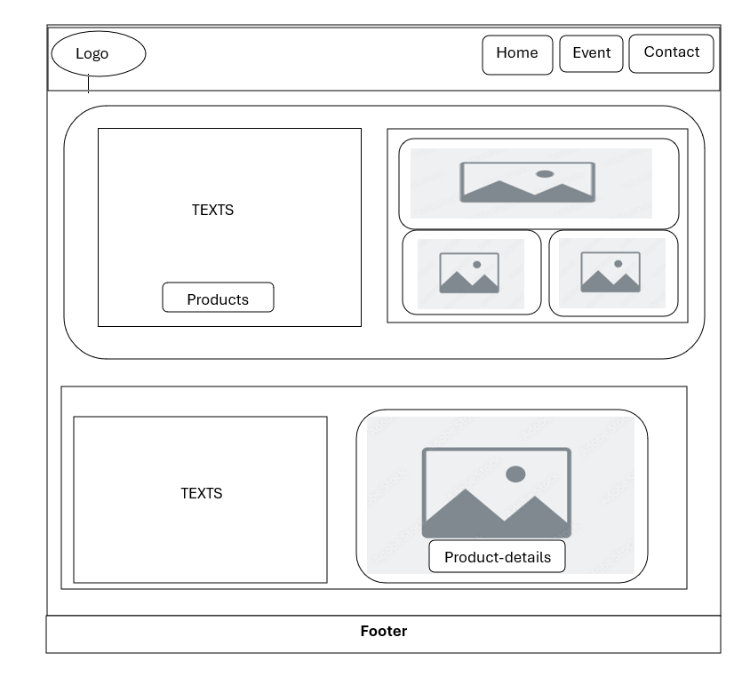
Home

Home
Events
Contact

Product1 Product2 Product3

Product-details
Product-details
Product-details

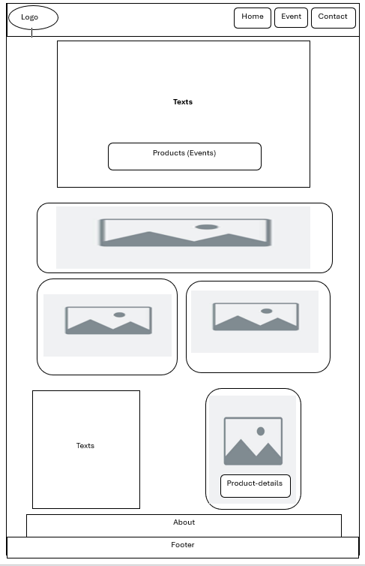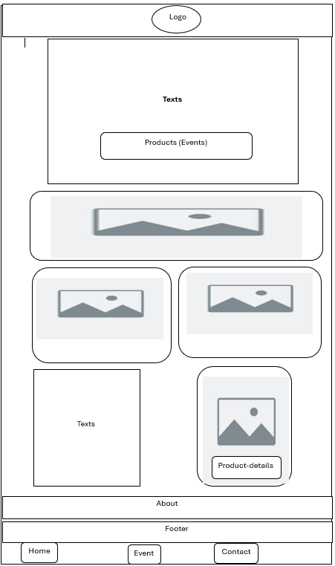

Note: All three above images is the wireframe for home page with different sizes of the screen for better responsiveness.
3. Mood board

?

3.0 Implementation
3.1 Features Developed, Implementation Processes and Challenges Encountered
Section 1: Home Page
The home page (index.html) is divided into sections using the <section> element. Short product descriptions are specified using <nav>, <ul>, <li>. These sections include images using <img> also there
are icon used for better responsiveness in small screens such us <svg>. There is an article with an image describing each page.

Section 2: Events Page
There is a link provided in the header of the home page to the Events page. Event page includes all the event available along with their meta data rendered from Json-file. This page also has the header which
provides the user to work through other pages. Each event has a clickable link called detail which is the specific detail about the specific event in the event-detail page.

Section 3: Events-detail page
Event detail page is the meta data of a specific event that enables users to book their spot by registering (registering will be in the second term) to the event.
Section 4: contact page
Contact page is the page where a user can contact website owner (Shaheerullah Fayzi) for their enquires. By filling a form simply by their name email address and messages.

Documentation:
Section 5: Animated Thumbnails

The whole body of the pages uses fade in animation and using @keyframe to fade the body into the screen as follows:

.fade-in {
opacity: 0;
animation: fadeIn 0.4s ease-in forwards;
}

@keyframes fadeIn {
to {
opacity: 1;
}
}
Almost all pages of the website contains animated product thumbnails that can be expanded when clicked on or hovered. As specified in the brief, this incorporates.
The image thumbnails are implemented using CSS transition and transform by targeting their class or id as follows:
.event-button{
transition: all 0.3s ease;
}
.event-button: hover {
transform: scale(1.05);
}

Challenges Encountered: The challenge encountered was how to get the metadata from the json file and populate the event-detail page

Summary and Conclusion

The Event Booking Website was developed to simplify event discovery and booking, featuring intuitive navigation, dynamic content, and responsive design. Built with HTML5, CSS, JavaScript, and jQuery, the website includes navigation, event details, contact forms, and animations optimized for various devices. Metadata for events is dynamically rendered from a JSON file, ensuring real-time information.
The project successfully met its objectives, providing a functional, user-friendly platform. Challenges, such as handling JSON metadata, were effectively resolved, enhancing technical skills and reinforcing key web development concepts.

Documentation

Sources and References
All images taken from google search:
https://www.google.com/url?sa=i&url=https%3A%2F%2Fwww.happyscribe.com%2Fblog%2Fen%2Fsubtitles-business-presentations-advertisement&psig=AOvVaw1jwIb9gX2OTnpO7s8R5A_5&ust=1737140613561000&source=images&cd=vfe&opi=89978449&ved=0CBAQjRxqFwoTCMDjwaL3-ooDFQAAAAAdAAAAABAE

https://www.google.com/url?sa=i&url=https%3A%2F%2Fsocmedhe18.wordpress.com%2Flocation%2F&psig=AOvVaw32m7eQ_kR0Ot_1mF42SRbV&ust=1737140658865000&source=images&cd=vfe&opi=89978449&ved=0CBAQjRxqFwoTCNDgrLL3-ooDFQAAAAAdAAAAABAE
etc.
<svg> icons created with chatGpt.

